First Grade Newsletter September 2020
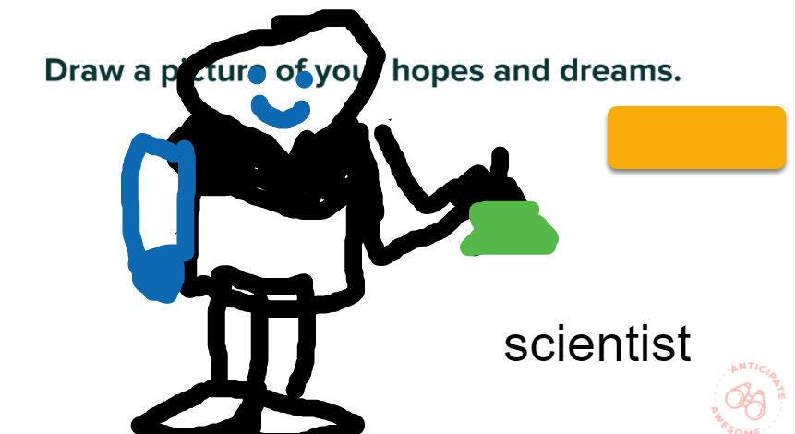
Upcoming Events:
September 29th-Back to School Night
6:00 (Spanish) | 6:45 | 7:30

October 12- School Planning Day. No school for students.
October 30- Quarter 1 Ends
November 2 & 3 - Parent-Teacher Conferences. No school for students
September in Review
These first few weeks of school, we focused on learning classroom routines, procedures, and each other. We also learned about:
* How to build good reading habits and stamina.
* How to write stories that have a beginning, middle, and end
* How to be a mathematician that can count and write numbers 0-30, skip count, and use a calendar
* How to be a good citizen

What Are We Learning in October?
Reading & Writing: Students are reading and writing about characters. In reading, students are noticing how character’s and their feelings change in a story. Readers are also learning how to double to check to make sure a word looks right and sounds right. In writing, students are writing stories with characters. Students are also learning how to add to their story by including talking, feeling, and action.
Math: We are working on our Addition and Subtraction Unit. We are learning about writing and solving addition and subtraction equations and story problems. We will explore ways to make 10. We will also learn about equality by finding the missing number to make an equation true.
Science: We are learning how to be a scientist and use our senses to make observations. We are also learning about Deciduous and Evergreen trees. We will learn about the needs of a bird.
Social Studies: We will be learning about Past, the first Virginians and the Present.

Reminders:
* If there are any changes to your child's schedule, please email your child's teacher AND TimberLaneES.Attendance@fcps.edu

