Sixth Grade Newsletter
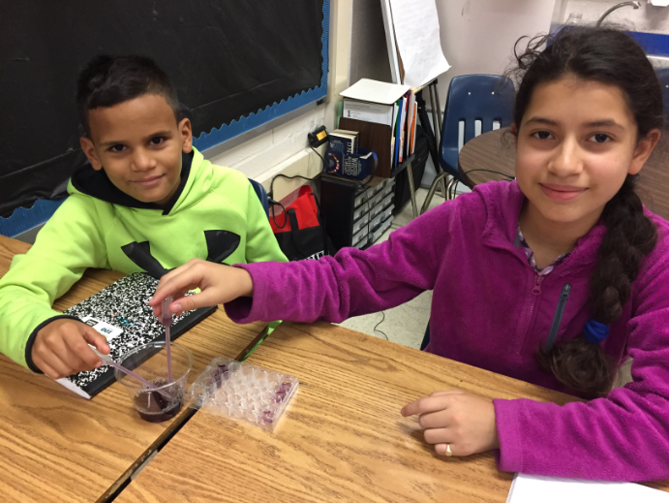
Welcome back to school! This is going to be an exciting and successful school year. We are looking forward to meeting all parents on Back to School Night which will take place virtually Tuesday, September 29th at 6:00 pm. More information will follow. If you need to contact us please don’t hesitate to email or reach out through the Talking Points App.
What Are We Learning?
Reading: We will be learning about our identities as readers! We have been reflecting on our past readings in 5th grade. This will help us to figure out who we are as readers in 6th grade. We have begun setting goals for ourselves as readers and will check in with those goals periodically throughout the year. We will begin practicing on what connections, feelings, or questions we have when we are actively reading. To help with this, all students should have a book on myOn or a book at home!
Writing: We will be learning about our identities as writers! We have been reflecting on our past writing creations from 5th grade. This will help us to find out who we are as writers in 6th grade. We have begun setting goals for ourselves as writers and will check in with those goals periodically throughout the year. We will be starting to brainstorm topics to start writing our first piece!
Math: We will be learning a lot of new material this year as we embrace a growth mindset. We will begin with learning about ratios and how to represent them as fractions, decimals and percents. We will also take the iReady math diagnostic to support individual learners. Please make sure your child is studying his/her multiplication facts every night. It is essential that 6th graders know their multiplication facts
Grade 6 Advanced Mathematics: We are building on our understanding of ratios by converting, comparing, ordering, and solving real world problems involving rational numbers. The students are increasing mathematical discourse by questioning and critiquing the reasoning of others. Students are also working on a ratio’s project of their choice and will present their understanding with the class.
Science: The 6th grade overarching theme this year is systems. We will begin investigating how the solar system is organized and understand how various bodies within it interact.
Social Studies: To begin this year, we reflected and had peer discussions about how to be a safe internet user. With class being remote this year, students learned about how to be a great virtual civilian, friend, and student!

Upcoming Events Reminders
9/29 @ 6:00 Virtua lBack to School Night  10/7 Interims mailed home  10/30 First Quarter ends | 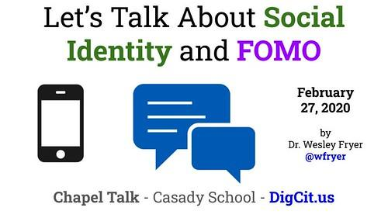Please download the Talking Points App to send and receive messages from your student’s teachers.  Talking Points Codes:  Culliton: XSXMQM  Nelson:CXDAQC  Ney: 9QKPTA  Shaw: DTTD12  Lohr: SNT6RZ

Reminders:* If there are any changes to your child's schedule, please email your child's teacher AND TimberLaneES.Attendance@fcps.edu. Use this email if your child will be late, absent, or is unable to attend school the entire day.

