Kindergarten Newsletter October 2020
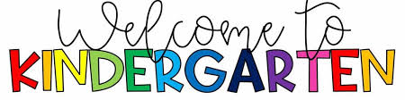
Reminders:
- Please sign into your child’s google meet by 9 am every morning!
- Please check Google Classroom for choice boards and tiger times for your child.
Upcoming Events:
October 12th-No School
October 30th- End of quarter
What Are We Learning?
Reading-Our Kindergarten students will explore different genres and authors to determine the types of books they love to read. They will also be learning how to share their ideas about text with others.
Writing-The students will be learning how to communicate their ideas by talking, drawing pictures, and writing. They will also be learning how to share their ideas with others.
Math-Our counting unit is beginning in the month of October! Students will be exploring how to count a group of objects, write numbers, orally count forwards and backwards, and skip count by 10s.
Science- Kindergarten students will be learning all about ants and pumpkins.
Social Studies- Students will be talking about making choices and positional words. We will also be learning about the Positivity Project.

The Kindergarten Team appreciates all your support!

